Submission Guidelines to Videojogos 2018
Name Surname¹, Name Surname², and Name Surname²
¹ Author affiliation, Town, Country
Author email
² Author affiliation, Town, Country
Author email
Abstract. Summarize the contents of the submission with an abstract of 250 words (max.).
Keywords: Specify a maximum of 4 keywords, separated by commas.

1 Introduction
Format all text using the styles provided so that texts can be easily edited for publishing in the online proceedings. Submissions should be delivered as PDF files, while the final documents for publication should be delivered in Word format.

2 Preparation of the Document
Author’s names should not include academic titles or descriptions. Names of multiple authors should be separated with commas. Affiliations should be composed below the name or list of names and include town (if it is not already part of the affiliation itself) and country. Email contacts should be composed directly below the affiliations. Multiple affiliations should be marked with superscript numbers and composed in new lines as shown in this template. Initial submissions should be totally anonymized for the reviewing process. Submissions of artworks, exhibits, or performances may include links to multimedia files where the authors can be seen working/performing, but names and identifications should be avoided as much as possible.
Please don’t leave empty lines between paragraphs. Format longer citations as indented paragraphs, without quotes, and format short citations with double quotes and inline, such as “the computer is not fundamentally a wire or a pathway but an engine.” (Murray 1997)
Here’s a new one for the psychopathology manual: possiplexia, being overwhelmed by possibilities—either freezing in the face of them, like people I know, or trying to grab them all, like me. (Nelson 2010)

2.1 Headings
Compose all headings with title-case and the appropriate styles and number the first two levels of section headings as demonstrated in the table below.

Table 1. Levels, typeset examples and font size and style normalization for headings
Level | Example | Size and style
First | 1 Introduction | 16 pt, bold
Second | 1.1 Second Level | 12 pt, bold
Third | Third level | 12 pt, bold
Fourth | Fourth Level | 12 pt, italic

2.2 Figures and Tables
Table captions should be composed above the table, while figure captions should be composed below the figures, both using the same style. All captions should be numbered sequentially and should include a reference to the source whenever necessary. All images should be prepared with a minimum of 1.000 px width, so that they can be zoomed in the published proceedings. The images should be composed inline in the Word file but final versions for publication should include higher-resolution images as attachments in PDF, PNG, TIF or JPG.
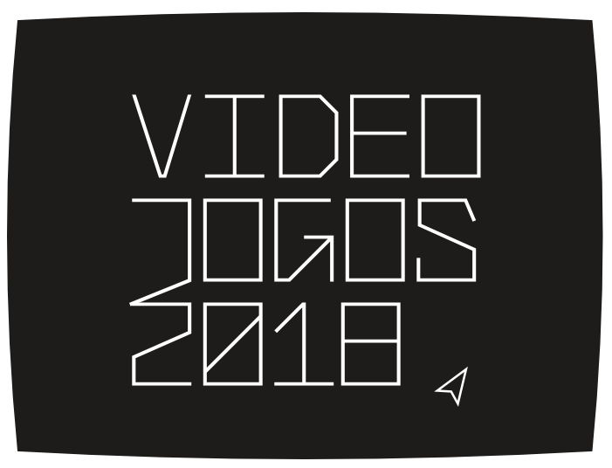

Fig. 1. Videojogos 2018 logo

2.3 Media Assets
Media assets such as audio, video, etc., should be represented in the original submission as a screenshot or static images with a URL pointing to an online version of the asset in its caption. The publication version should attach them for publication in the proceedings.

Fig. 2. A video asset (http://www.vimeo.com)

2.4 Program Code
Program commands in the text should be set in the appropriate style. Use the caption style for notes after the code:
background(loadImage("rockies.jpg"));
PImage img = loadImage("degaul.jpg");
image(img, 0, 0);
blend(img, 0, 0, 33, 100, 67, 0, 33, 100, DARKEST);

Example of a pixel blend function from http://processing.org/reference/blend_.html

2.5 Notes
Superscript references to notes should be composed either directly after the word, phrase or sentence to be discussed or, immediately following the punctuation mark, if applicable. Number all footnotes sequentially and do not include any footnotes in the abstract.

2.6 Citations and Bibliography
Citations in the text should be labelled with (Author Year) or (Author Year, page) following the Chicago Manual of Style conventions. The references section should be organized alphabetically and chronologically. All references should be written in the Latin alphabet and where applicable list the original language at the end of the transcription or translation of the title, e.g., (in Chinese) or (in Greek).
The Chicago-Style Citation Quick Guide can be accessed online at http://www.chicagomanualofstyle.org/tools_citationguide.html

3. Technical Rider
If you’re submitting a demo, please include a full technical rider and other setup requirements we should be aware of. Please list all equipment you’ll be able to provide and what additional equipment you will need.

4. Additional Information
The submission of the final version of the article constitutes an authorization for publishing at the Videojogos 2018 proceedings.
Should you have any questions, please contact vj2018@fba.up.pt
Acknowledgements. If necessary, they should always be composed with a run-in heading formatted in bold. They should always be composed in the end of the text prior to the references.

References
Bolter, Jay David, and Richard Grusin. Remediation: Understanding New Media. Cambridge, MA: The MIT Press, 1999. 2002.
Murray, Janet H. Hamlet on the Holodeck: The Future of Narrative in Cyberspace. Cambridge, MA: The MIT Press, 1997.
Nelson, Theodor H. Possiplex: Movies, Intellect, Creative Control, My Computer Life and the Fight for Civilization. Hackettstown, NJ: Mindful Press, 2010.
(Revised 27 July 2018)

This is an example of a footnote.

